

College of Information and Computing Sciences



Salon Management System
Software Requirement Specification

Information Technology Project 2022

Submitted by:

ODESSA MAE SIRIBAN
NICOLE ROLDAN
KRYSTAL MAE CARASCON
FROILENE TAMBA
PINKY JANE RAQUINO

Submitted to:

MARIA KHADIJA XYNEFIDA P. ONTIVEROS

Date of submission
JANUARY 2022
Table of Contents
Table of Contents ii
Revision History ii
1. Introduction 1
1.1 Purpose 1
1.2 Document Conventions 2
1.3 Intended Audience and Reading Suggestions 2
1.4 Product Scope 2
1.5 References 3
2. Overall Description 4
2.1 Product Perspective 4
2.2 Product Functions 4
2.3 User Classes and Characteristics 8
2.4 Operating Environment 9
2.5 Design and Implementation Constraints 10
2.6 Project Documentation 10
2.7 User Documentation 10
2.8 Assumptions and Dependencies 10
3. External Interface Requirements 11
3.1 User Interfaces 11
3.2 Hardware Interfaces 14
3.3 Software Interfaces 14
3.4 Communications Interfaces 14
4. System Features 15
4.1 E-R Diagram 15
4.2 Use Case Diagram 16
4.3 Use Case Scenarios 17
4.5 Activity Diagrams 23
5. Other Nonfunctional Requirements 31
5.2 Performance Requirements 31
5.3 Safety Requirements 31
5.4 Security Requirements 31
5.5 Software Quality Attributes 32
5.6 Business Rules 33
6. Other Requirements 34
Appendix A: Glossary 34

Revision History
Name | Date | Reason For Changes | Version

Introduction

Purpose
The Software Requirements Specification (SRS) will provide a detailed description of the requirements for the Salon Management System (SMS). A software requirements specification (SRS) is a comprehensive description of the intended purpose and environment for software under development. The SRS fully describes what the software will do and how it will be expected to perform.
Salon management system with a window-based interface can allows you to work more conveniently even if you are new to computers. Due to window-based interface it also allows you to open many windows at a time. On the left-hand side of the main window there is a tree structure that allows you to fast access the various functions of the software. In the salon software there are different forms for different users with various privileges.
There is also built-in help available in our salon management system which can give you help for the software and there is also a tutorial and a start panel to help you learn all the basic features and functions very fast and easily.
Salon management software also provides you with a way to manage your customer data. By using this software, you can review the history of the discount you have offered to customers or the services that you have provided to your customer. This salon software also organizes the products in a tree structure that allow you to perform various functions easily such as adding a product under a product category or to change the product group.
For a better salon management, you can use a better salon management system such as blond management system which can take, you're all the worries about managing your salon. By using its powerful features, you can make your business more and more manageable day by day.

Document Conventions
The document is prepared using Microsoft Word 2013 and has used the font type 'Times New Roman'. The fixed font size that has been used to type this document is 12pt with 1.5 line spacing. It has used the bold property to set the headings of the document. Use case scenario is written according to Alistair Cockburn’s template. UML diagrams have been created according to UML 2.0 standards. Standard IEEE template is the template used to organize the appearance of the document and its flow.

Intended Audience and Reading Suggestions
While the software requirement specification (SRS) document is written for a more general audience, this document is intended for individuals directly involved in the development of Fantastic Salon. This includes software developers, project consultants, and team managers. This document need not be read sequentially; users are encouraged to jump to any section they find relevant.
Brief outline of the document is:
1. Overall Description
2. System Features
3. External Interface Requirements
4. Non-Functional Requirements

Product Scope
The introducing software, Salon Management System which is going to be implemented for Fantastic Salon will automate the major operations of the Salon. This system keeps track of employee salaries, inventory, and customer data along with billing. This is a fully equipped system that alone manages the entire functioning of a hair salon. It maintains stock of inventory coming in. It also manages individual employee salary. The system is even equipped to manage customer billing and data storage.

The system works as follows:
- Administrator may login to the system.
- He may then manage and check employee salaries due date and payment to be made.
- The system also keeps track of inventory coming in.
- An employee login is also present for customer billing.
- As the employee enters various services, the system calculates the bill and generates the bill.
- This customer data is also separately stored in a database.
References:
World Wide Web

Software requirements specification (SRS)
Software Requirements Specification (SRS) (techtarget.com)

Salon Management System: Making Thing Easier
Salon Management System: Making Thing Easier | Beauty Salon Software (wordpress.com)

1.5INTENDED AUDIENCE AND READING SUGGESTIONS
15 INTENDED AUDIENCE AND READING SUGGESTIONS While the software requirement | Course Hero

Salon management System
Salon management System Project (nevonprojects.com)

The Ultimate Guide to Salon Management
Salon Management: Ultimate Guide to Boost Salon Productivity (miosalon.com)

Overall Description

Product Perspective
The Salon Management System is a the newly introduced system will provide an easy access to the system, and it will contain user friendly functions with attractive interfaces. The system will give better options for handling such problem, for the errors occurring in calculations and all the other required tasks that has been specified by the client. The outcome of this project will increase the efficiency of almost all the tasks done at the Salon in a much convenient manner. Effectively and efficiently managing a salon may be time-consuming, but with salon management software and a hint of automation, the whole process seems less trying.

Product Functions
- Make Reservations
- Add Payment
- Issue Bills
- Manage Staff (Add, Update, Delete, View)
- Manage Inventory (Add, Edit, Delete)
- Retrieve Reports (Staff payment, Income)
- Manage Users (Add, Update, Delete)
- E-mail notifications

Functional Requirements:

- Admin
• Admin can login into machine.
• Admin can delete/ edit records of consumer and salon
• Admin keep the data of all appointments

- User
• User can create account
• User can log in into the device
• Search for salons by means of: call, region location, city and many others.
• View and Edit Account data
• Make an appointment
• Specify stylist
• Cancel an appointment
• View Appointments
• Rate salon/stylist (can handiest rate Salons/Stylists after an appointment)
• View person ratings of salon and stylist (clear out by means of salon place, service)

- Salons Owner
• Create a salon account
• Log in into the gadget
• Edit Salon Account Information
• Add a Stylist
• Remove a Stylist
• Edit the services a stylist gives
• Add/remove beauty offerings of Salon
• View/Print schedules

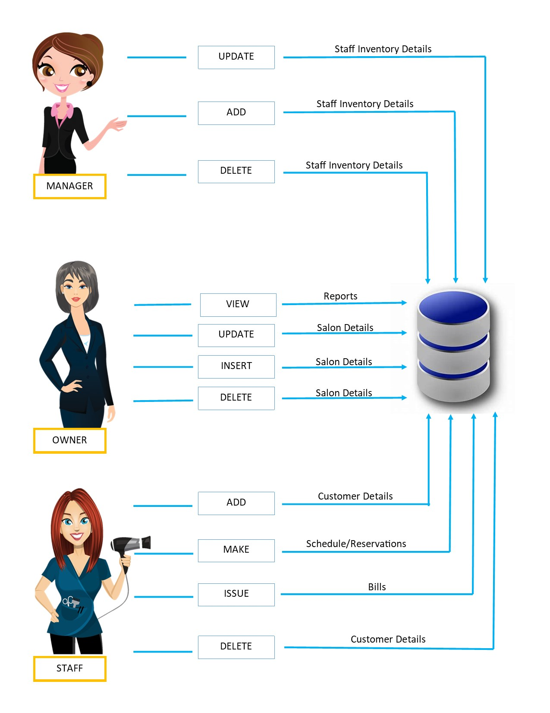
Figure 2.1.1 High Level Architecture

Functional Requirements

Function 1 | Add Customer
Input | Member code, Phone number, Company, Name, E-mail, Gender, Address
Output | Database Record, Database successfully updated message
Processing | Validate the given details and record the information in to the database.

Function 2 | Add Satff
Input | Code, Employee Name, Employee Address, NIC, Salary, Name Age, Occupation, E-mail
Output | Database Record, Database successfully updated message
Processing | Validate the given details and record the information in to the database.

Function 3 | Add Payments
Input | Total, pay time, Credit card details, online payments
Output | Database Record, Database successfully updated message
Processing | Validate the given details and record the information in to the database.

Function 4 | Issue Bill
Input | Billing no, Quantity, Price, Taxes, Date, Services, Unit
Output | Printed version of the bill
Processing | Validate the given details and total cost is calculated according to the  Services gain by the customer.

User Classes and Characteristics

User Classes
There are three user levels in Hotel Management System of Hotel Gayana.

- Owner
- Manager
- Staff

Characteristics of User Classes
Owner:

Salon managers are responsible for hiring and training staffs, promoting high levels of customer service, advertising their services, and ordering and selling hair or beauty products. They need to ensure all staff are complying with occupational health and safety regulations. The role of salon manager is so complex, it is imperative to fill this role with someone that has a wide variety of experience in the field as opposed to a specialty. This individual must also have great business acumen and understanding of how to operate the financial and interpersonal aspects of managing a hair salon

Manager:

A salon owner is the driving force behind a beauty salon; he or she has complete authority over the salon's operations. You're in charge of creating a profit, as well as branding, marketing, locating space, employing employees, and managing cash flow. You have complete control over the style, pricing, and ethos of your business, whether you want a local hair salon with reasonable haircuts or a high-end luxury spa with high-end amenities.

Staff:

Roles in beauty salons:
The beauty business is so diversified, there are a plethora of professions to choose from, with varying skill levels necessary for each. Allow me to go through some of the most popular. Barbers As a result of the fewer diversified services they provide, barbershops have a considerably flatter structure than hair salons do. Salon receptionist A salon receptionist is usually assigned to keep track of appointments, ensure that clients are comfortable, and assist in keeping the salon clean and tidy. A salon receptionist does not always need to have any hair and beauty qualifications or skills, but they must be well organized, presentable, and, most importantly, good with people to be successful in the role. Nail technician Manicures and pedicures, extensions, and massages are all provided by nail technicians. A nail technician should be at least somewhat qualified, and if they're providing any specialty treatments, they should have completed the appropriate training (s) Makeup artist Makeup artists work with customers and hairstylists to create a look that everyone agrees on, then apply the makeup appropriately. Waxing specialist When you consider how rapidly the popularity of waxing for both men and women is growing, it's no wonder that the function of waxing professionals has expanded. Professionals that are also competent to conduct other treatments such as hair styling or cosmetics artistry may wax, although it can be a separate area of expertise for others.

Operating Environment
Hardware and software requirements

Hardware:
- Operating System Supports all known operating systems, such as Windows, Linux
- Computer 512MB+ RAM, monitor with minimum resolution of 1024x768, keyboard, and mouse
- Hard Drive should be in NTFS filesystem formatted with minimum 10 GB of free space
- A Laser printer will need to be used to print these reports and notes

Software:
- Software is designed to run on any platform above Microsoft Windows 7 (32bit).
- Microsoft .NET Frameworks 4.0 or above.
- Microsoft SQL Server Management Studio Express 2010.

Design and Implementation Constraints
Software development team provides their best effort in developing the system. The design and implementation constraints are applied in this system to ensure the reliability of it. The availability of an android and IOS was considered for salon management system. In terms of interface design of the system, we had simple yet meaningful interfaces and attractive.

Project Documentation
Project Documentation section reveals the all the details about documents created by the project team so far of this project. It includes project charter and project proposal.

- Project charter: - This document provides the basic information about the team and their responsible in developing functions, the background of the customer and the nature of the main problem.

- Project Proposal: - The proposal of the project consists with the problems that are being identified by the customer, and the solutions that are going to implement using the proposed system.

User Documentation
User manuals provide to the customers that will give a clear understanding in interacting with the system. The manual was written in a simple understandable language. The manual will also be available in the system for the customer who have a reservation.

Assumptions and Dependencies
Some of the software used in the system's implementation is expensive, and the client had also agreed to pay the full price. It is assumed that the client will not change his mind during the next stages of software development. And if the client used an open-source operating system, the SRS must be modified accordingly.

External Interface Requirements

User Interfaces
User friendly dashboard of system
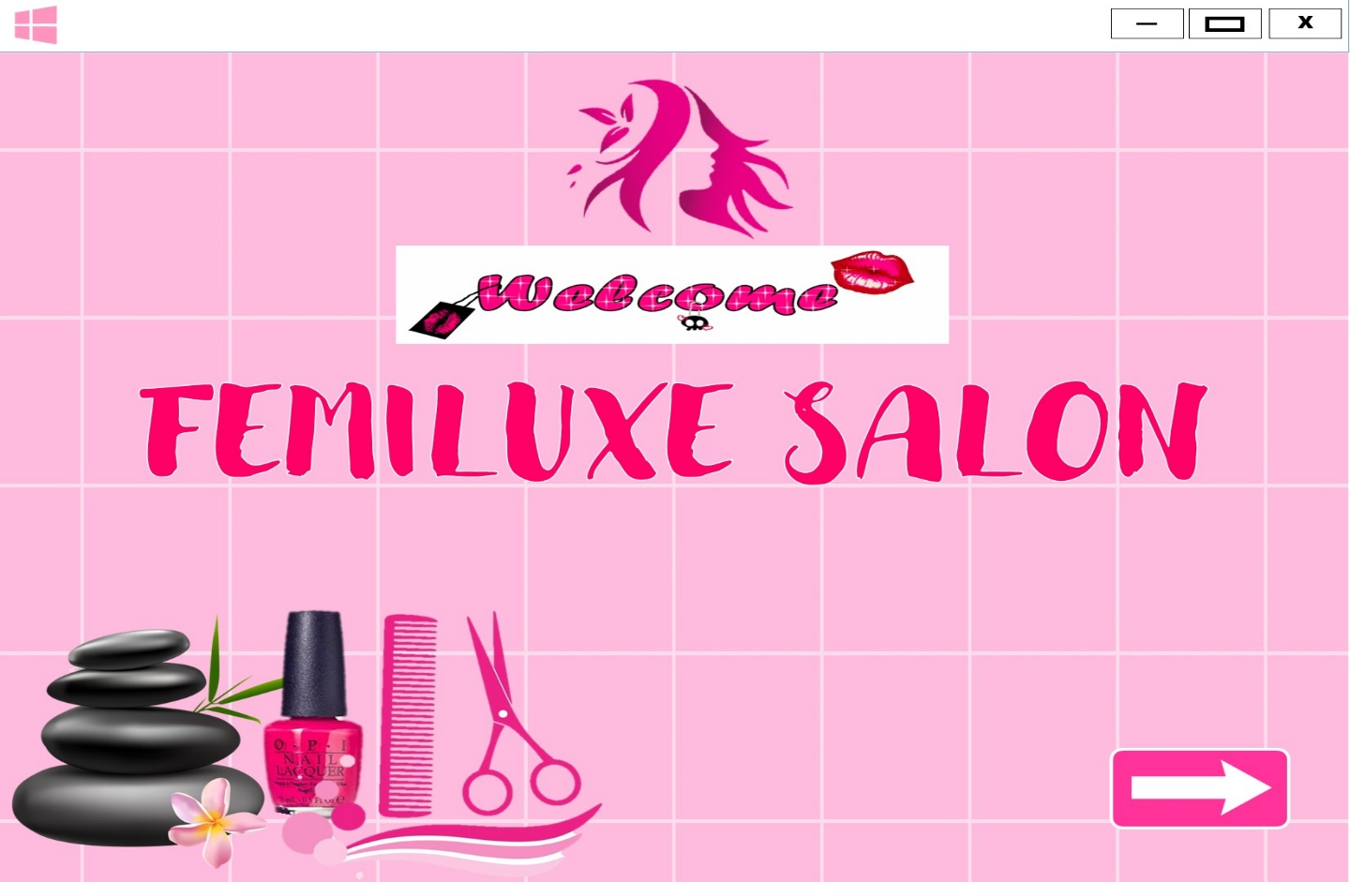

Login interface is used to login to the system using username and password for three different users

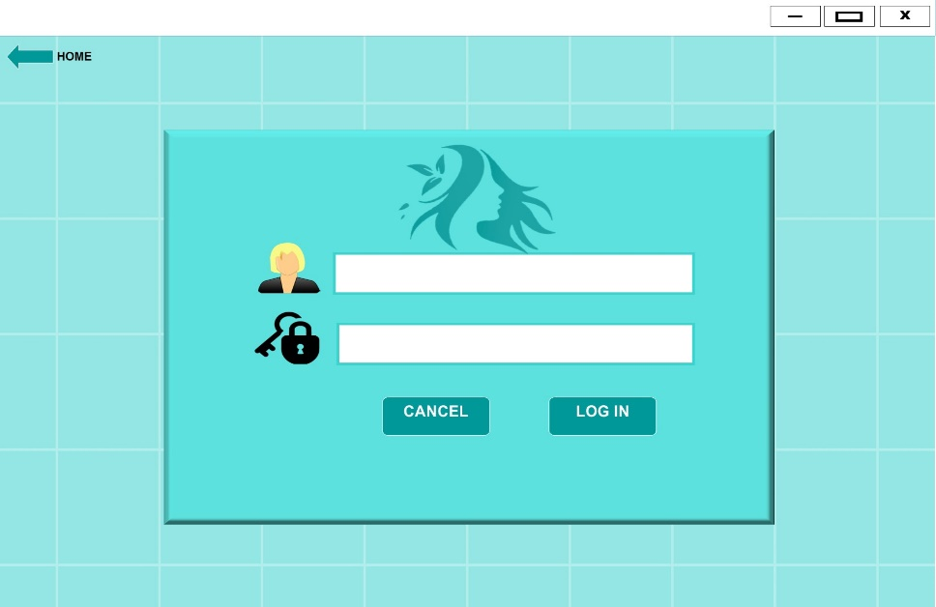

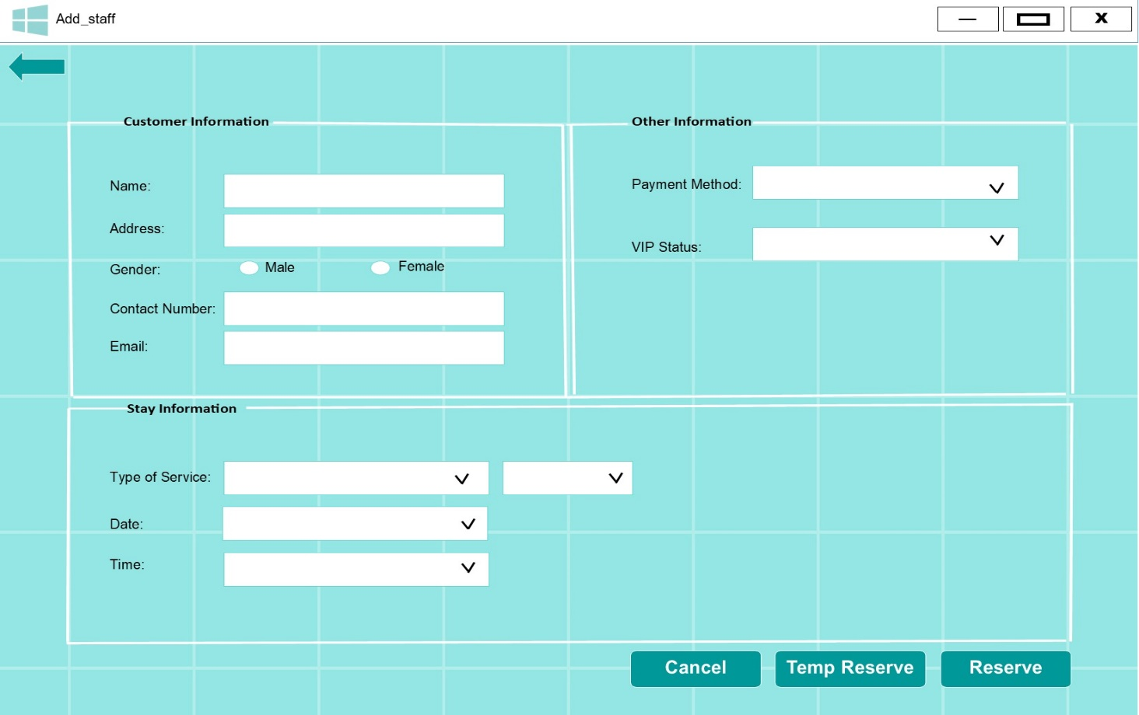
Adding New Customer to the system

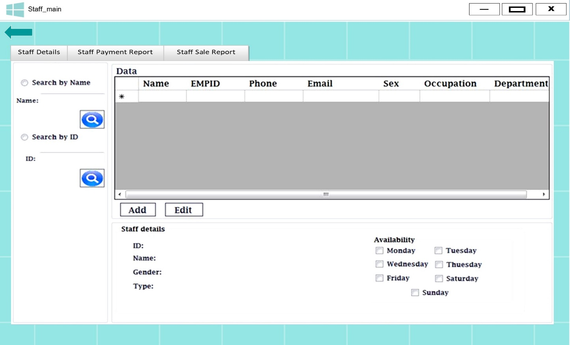
Staff management
Adding a new staff member
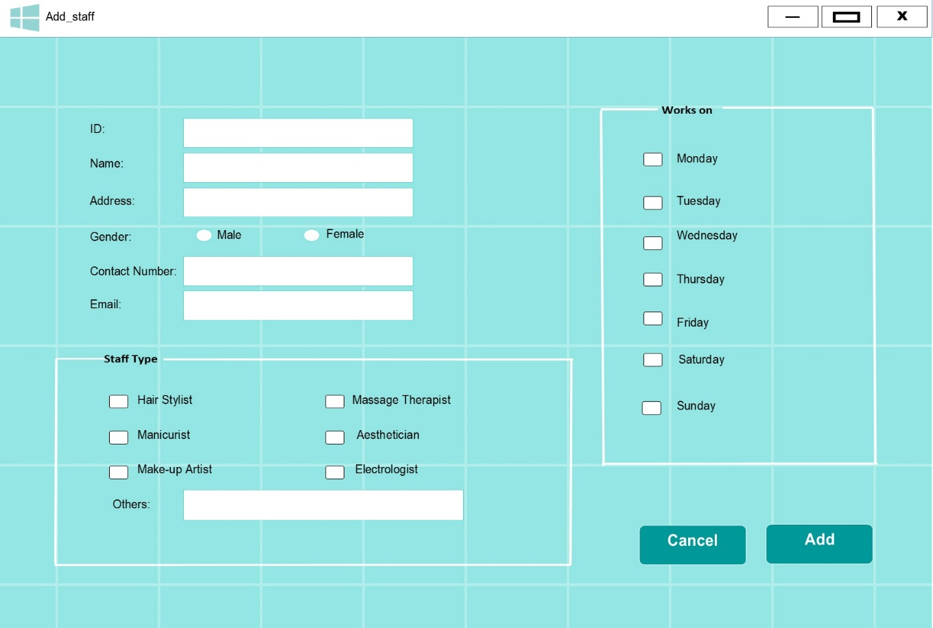

Make Reservation
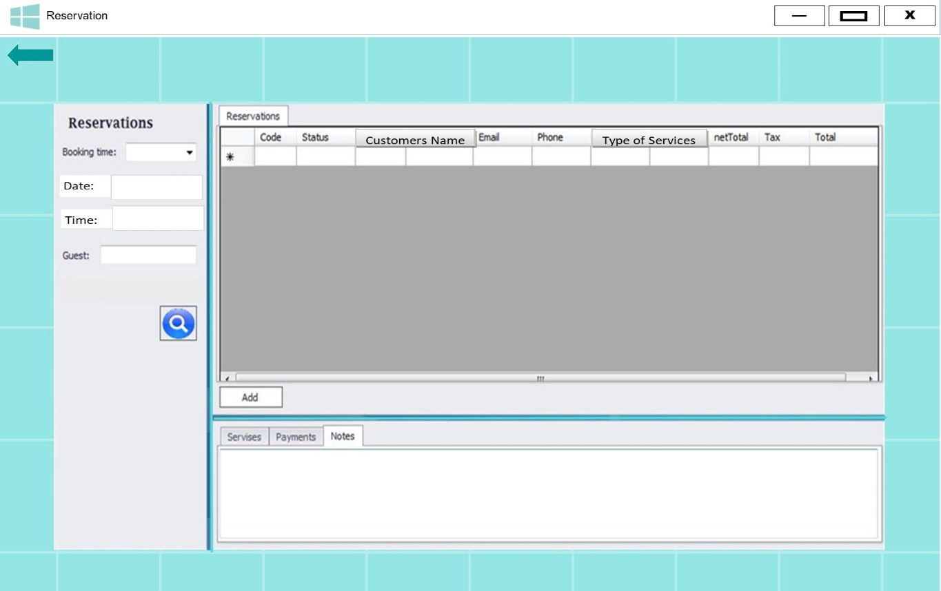

Hardware Interfaces
A specific computer must match with the above-mentioned requirements to gain the maximum benefits from the system.
Reservation alerts will be sent to the staff as an e-mail notification and customer should be able to keep a stable internet connection.
A laser printer will be needed when printing bills and several reports.

Software Interfaces
The software is going to be installed to have a windows operating system, Salon software automates and manages salon and spa operations, often offering easy integration with cash registers, barcode readers, and other point of sale hardware. Hair salons, tanning salons, beauty parlors, nail salons, massage therapists, and day spas use these systems to add efficiency and value to a variety of business processes, including appointment scheduling, client management and marketing, employee data, commission calculations, inventory management, payroll, and more.

Communications Interfaces

Managing customer base through appointment handling, salon will notify about the cancelation of the appointments, staff members and customers are aware about appointments because of SMS notifications. If there is a reservation an e-mail notification will be sent to both staff and customers, the user of the system also updates the customer when the salon is closed or open. Manual billing and payment handling will omit, and everything will be tracked through the system. And most of all having a stable internet connection provides good services.

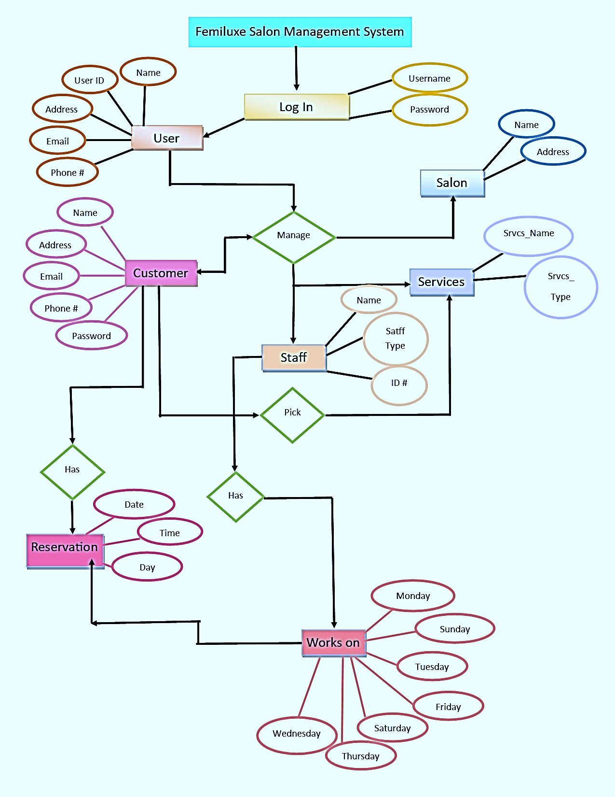
System Features

E-R Diagram

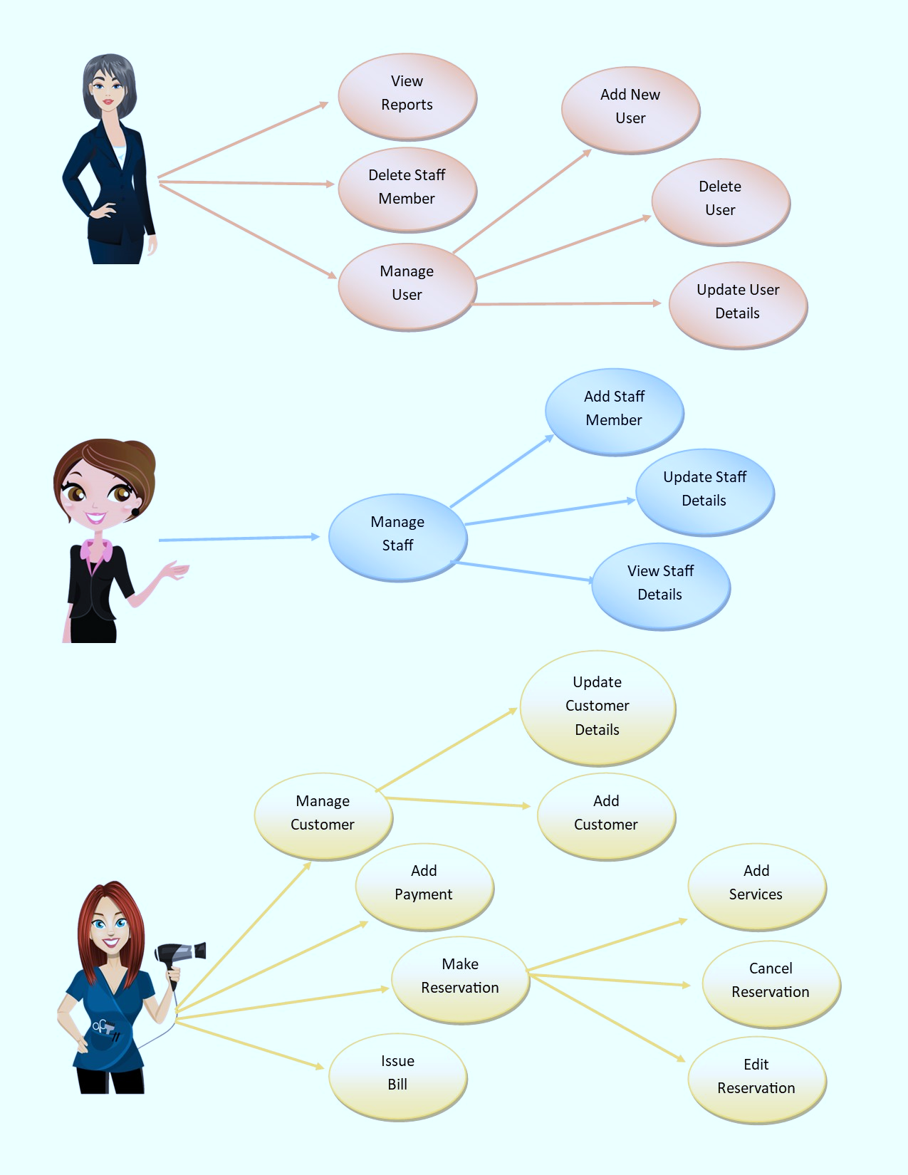
Use Case Diagram
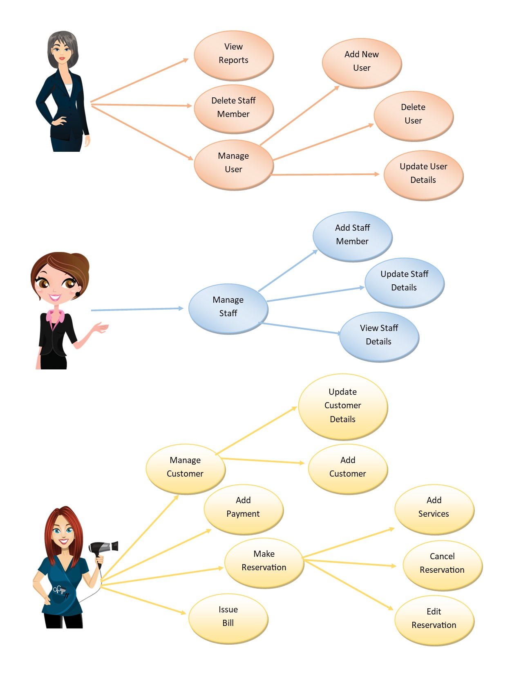

Use Case Scenarios

1)

Use case Name | Make Reservation
Goal | Add a new reservation
Primary Actors | Staff
Secondary Actors | None
Precondition | Guest shouldn’t already be existing
Post condition | Customer Details updated to include current Customer
Triggers
Main flow | Step | Action
Main flow | 1 | Staff enter guest details
Main flow | 2 | Customer selects what type of services they want
Main flow | 3 | System records customer’s name and address
Main flow | 4 | Staff confirms booking on system
Main flow | 5 | System generates confirmation receipt
Extensions

2)

Use case Name | Check Availability
Goal | To check whether the staff is available or not
Primary Actors | Staff
Secondary Actors | None
Precondition | Login to the system.
Post condition
Triggers
Main flow | Step | Action
Main flow | 1 | Display User interface
Main flow | 2 | Select Availability Tab
Main flow | 3 | Enter room type, duration, number of adults and children
Main flow | 4 | System check services availability relevant to each requirements
Main flow | 5 | Display available room details
Extensions | 4.1 | No services available for entered details and display “No services Available”

3)

Use case Name | Add Customer
Goal | Add a new Customer
Primary Actors | Staff
Secondary Actors | None
Precondition | Log in to the system
Post condition
Triggers
Main flow | Step | Action
Main flow | 1 | Staff selects “add Customer” button
Main flow | 2 | System prompts to fill out customer details
Main flow | 3 | System validates details
Main flow | 4 | Update database
Main flow | 5 | Display “Successful message”
Extensions

Extensions | 3.1 | Customer details are incorrect, Display the message "Unsuccessful" and display Add Customer option.

4)

Use case Name | View financial reports
Goal | View a financial report for specific time
Primary Actors | owner
Secondary Actors | None
Precondition | Log in to the system
Post condition
Triggers | owner clicks button “view reports”
Main flow | Step | Action
Main flow | 1 | System prompts the owner to select two dates
Main flow | 2 | Enter dates
Main flow | 3 | System will display the revenue for that specific time
Extensions

Extensions | 2.1 | If invalid details entered Display “unsuccessful” message and reenter interface.

5)

Use case Name | Delete Customer
Goal | Delete a Customer
Primary Actors | Staff
Secondary Actors | None
Precondition | Log in to the system
Post condition | A new customer is added to the system
Triggers | Staff clicks button “Delete Customer”
Main flow | Step | Action
Main flow | 1 | User interface displayed
Main flow | 2 | Select “delete Customer” option
Main flow | 3 | Enter guest details
Main flow | 4 | Valid guest details
Main flow | 5 | System display guest details
Main flow | 6 | System confirms deletion of selected guest
 | 7 | Update database
Extensions

Extensions | 4.1 | If invalid details entered Display “not found” message and redirect to main interface
 | 5.1 | Database is not updated, Display the message "Unsuccessful"

6)

Use case Name | Change Customer information
Goal | Alter properties such as telephone number or email of Customer
Primary Actors | Staff
Secondary Actors | None
Precondition | Log in to the system
Post condition | Customer details edited
Triggers | Staff clicks button “Edit Customer”
Main flow | Step | Action
Main flow | 1 | User interface displayed
Main flow | 2 | Select “Edit Customer” option
Main flow | 3 | Enter Customer details
Main flow | 4 | Valid Customer details
Main flow | 5 | System displays customer properties
Main flow | 6 | System alters the customer properties
Main flow | 7 | Update database
Main flow | 8 | Display “Successful” message
Main flow | 9 | Database updated
Extensions

Extensions | 4.1 | If invalid details entered Display “unsuccessful” message and redirect to main interface
 | 5.1 | Database is not updated, Display the message "Unsuccessful"

4.5 Activity Diagrams
Make Reservation

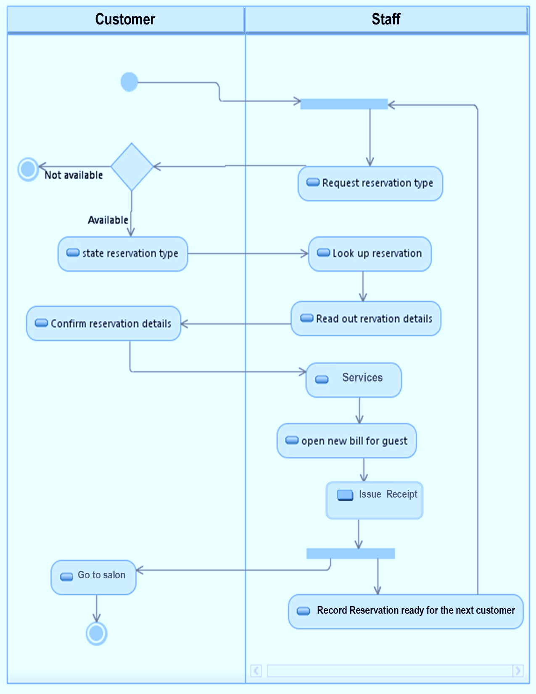

Search

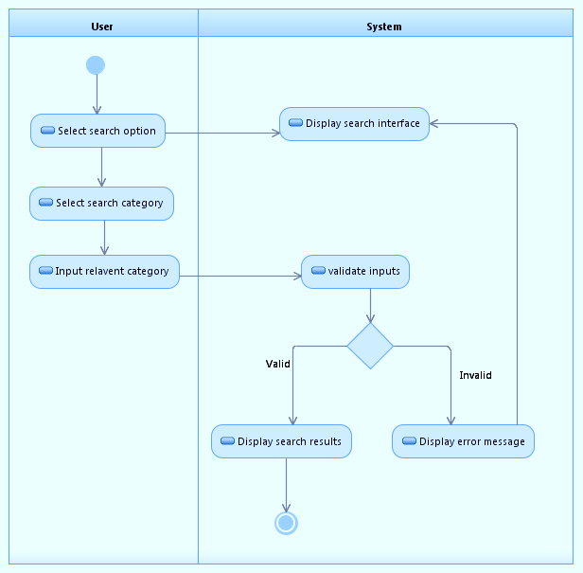
Delete a user

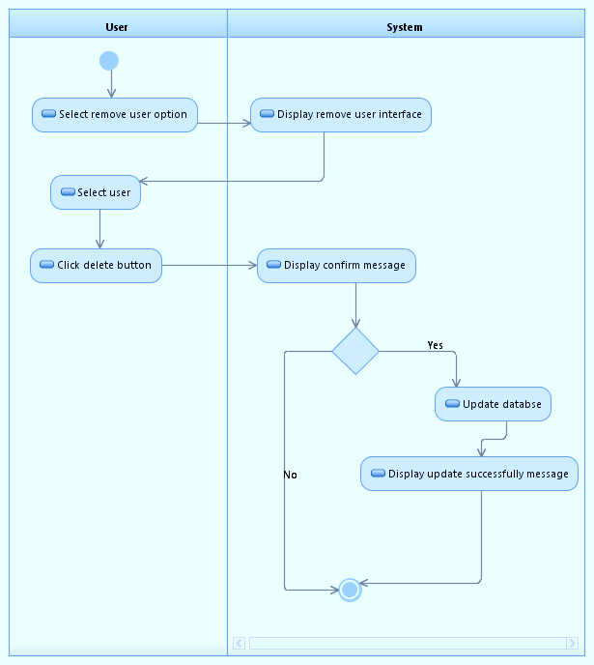

Add Payment

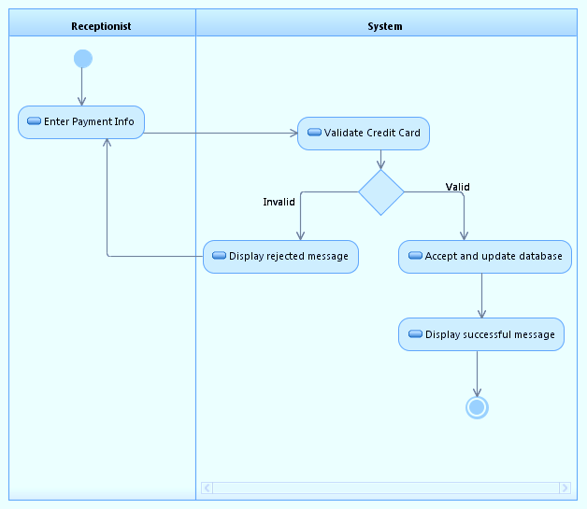

Add Guest

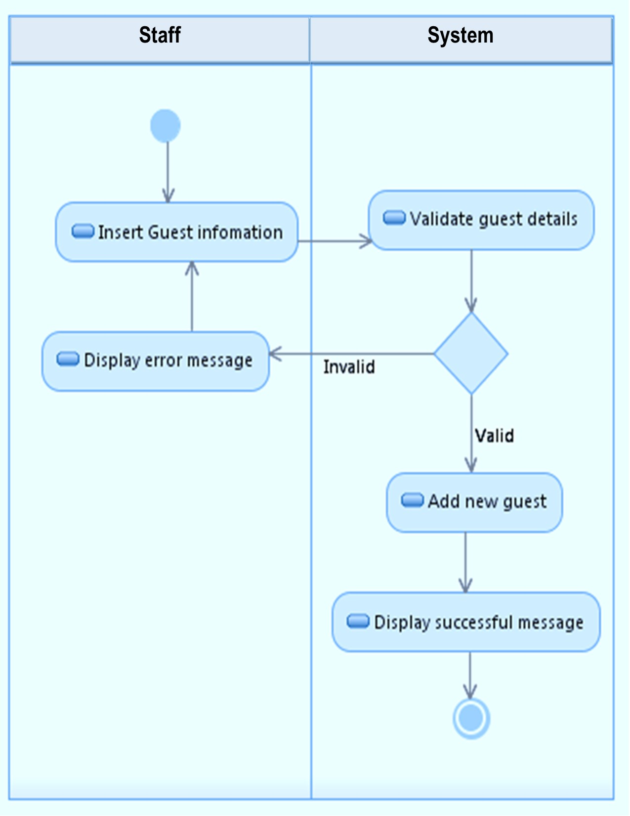
Add Staff

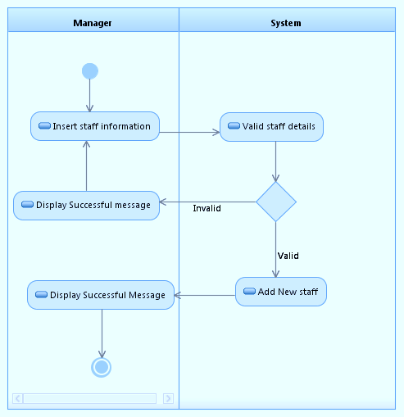

Delete user

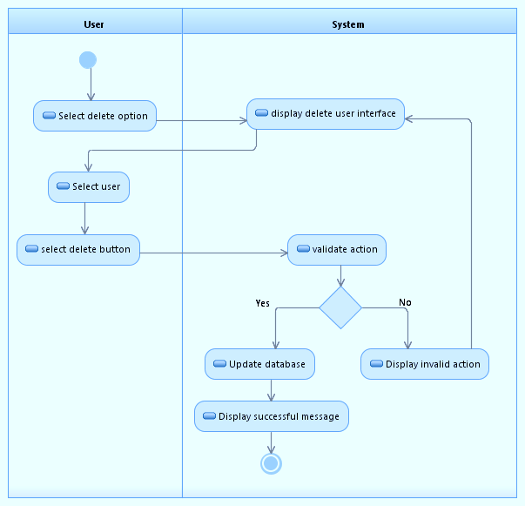

Create system restore point

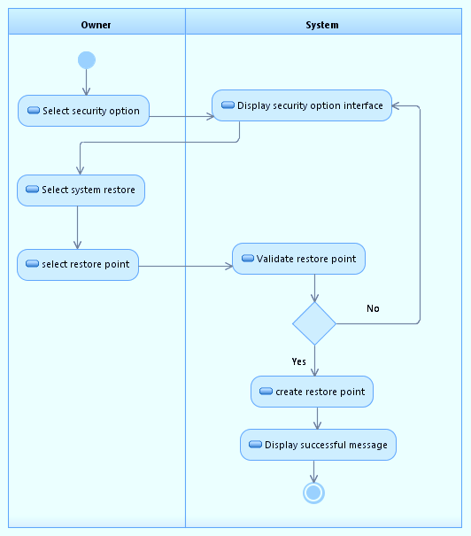

Other Nonfunctional Requirements

Performance Requirements
Suitable response times for things that are defined by performance criteria. Although the system was created with the least amount of system performance in mind, the system's performance is heavily dependent on the hardware and software components in the system that is being installed. When considering the system's timing relationships, the response time for user interface displays should be no more than two seconds. It provides quick access to system functionalities. The log in information must be confirmed within five seconds to ensure the system's efficiency. Providing queries in less than five seconds increased the efficiency of the search function.

Safety Requirements
There are some user levels in Salon Management System. Safety requirement evolved as a counterweight to the exploitation of a user’s in a system through by logging in that requires a username and password. There is an implied moral obligation placed upon a user to ensure the safe accessible functions of a system. This is to be achieved the safety requirements of the Salon Management System.

Security Requirements

The admin or employee must keep the client information safe and secured. the admin of the salon will be able to log in to the system and the employee will have the access for the reservation and the admin as well. the admin must properly protect the client’s information and The admin must have access or privilege to all systems or different systems to protect data when a user or clients will log in.

Software Quality Attributes
- Availability: - The system shall be available during normal salon operating hours
- Correctness: - the system is fully tested to have a good performance and to make sure that has no error at all.
- Efficiency: - the system is very fast in terms of responding; it takes only a few seconds to before it will respond.
- Flexibility: - the system has ability to add or update new feature to the system.
- Integrity: - the system has an ability to secure customers information using tables ,and databases to avoid problems not only information in the system but also the performance of the salon.
- Maintainability: - the system has an easy way to keep the system and making changes in the system.
- Portability: - The Salon Management System shall run in any Microsoft Windows environment also can run in mobile phones.
- Reliability: - the system took only few minutes when there is a failure and for recovery.
- Reusability: - the system could use all available features or components of the system even in other system as well
- Testability: - the system will be sorely tested to ensure the reliability and functionality of the system.
- Usability: - the system is user-friendly, and it takes only a few seconds before responding.
- Robustness: – the system has an easy access if there’s a failure it has a strength to handle the system accurately.
- Maintainability: – the system design must be simple but attractive to everyone. We will choose a programming language that is suitable in this system.

Business Rules
There are two main users for this system. The users are an admin and employees. For admin, correct username and password are required to access to the system. Once the username and password are verified and status of admin is authenticated, admin will be given access to the homepage of the system. However, if the login fails, admin will have to enter the information again. After gaining access to the homepage, admin can choose from customer record, appointment calendar, employee record, product record, service record, appointment planner, payment, and performance report. Noted that, only admin can manipulate the data of employee, service, and employee performance reports for security purposes.
The Femiluxe Salon Management System will function with three users: the owner, the manager, and the staff. The system is designed in such a way that responsibility and privileges are distributed in the following order: owner, manager, and staff. The role of the manager is chosen to free the owner's hands from constant interference with the system. As a result, except for those that are critical and important, most of the privileges that the owner has been delegated to the manager. Some of these features include system restoration and financial management, as well as salon income reports. The most frequently used features of the system are assigned to staff, who have less responsibility than the other two users. It is only possible to delete information from the system.

Other Requirements

When the system is fully constructed and uploaded to the client, a few sessions will be necessary to familiarize users with the system's capabilities, as well as some time to adjust to it. Following such sessions, a member of the development team must spend time in the system background for an agreed-upon amount of time. That time will be utilized to detect new defects that were not discovered during the previous stages of the development process.

Appendix A: Glossary

Type of Services – refers to the treatment available in a salon like manicure, spa, pedicure etc.

Booking – it’s like reserving something, if you want to have a reservation in our salon for treatment.

